Learn about Computing Machinery!
  - 5-Week Course Starting Monday February 2nd 3:30pm-4:30pm
  - 3rd – 8th Grade
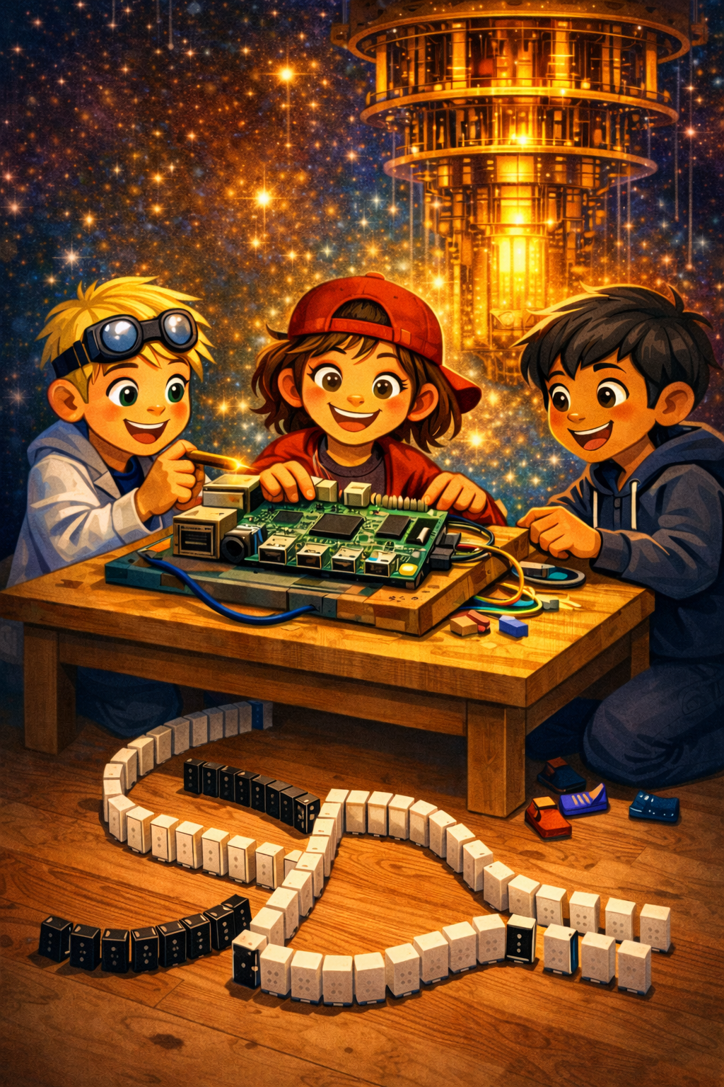 | Students will learn about computers’ past, present, and future while building and learning programming on their own Raspberry Pi Computer.  The course will demystify computers by using hands on experiments to simulate logical gates with dominoes, explain the components of a computer while assembling their very own system. We’ll install an operating system, write simple programs, and learn how networks and messaging work.  The class will be led by fellow parent Alan Andress. Alan’s background is in computer science, and he works in AI & Quantum computing for healthcare and life sciences organizations. He completed his BS and MS in Computer Science & currently attends a remote CS PhD program at his alma mater The Catholic University of America.
Limit 20 Kids  Cost: $175 (Add $25 for matching Keyboard & Mouse)  Name  Homeroom | - Please make Checks payable to Our Lady of Mount Carmel School  - 100% of the cost applies to hardware that your child will keep.  - Pickup in car loop.

